Workflow Functional Document

Application | NGERP - Centra
Workflow | Procure to Pay
Workflow Item Name | Return to Vendor

Description:

In Compiere ERP, the Return to Vendor process is used when you need to return goods to a vendor that were previously purchased, typically due to defects, overages, or incorrect items. This process updates inventory and creates the appropriate accounting entries to reflect the return.

Workflow Process:

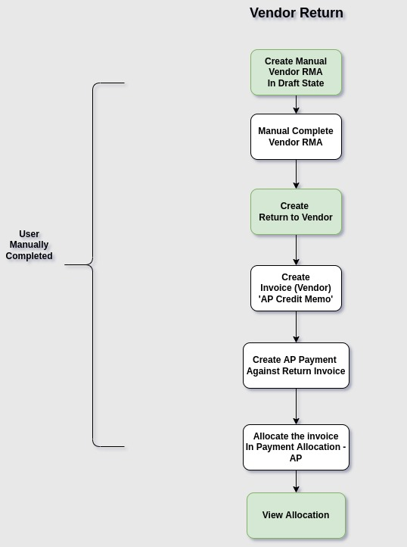

Business Rules:

- Vendor RMA can be creating it manually in the Vendor RMA window and user will manually complete the Vendor RMA.
- When Creating Vendor RMA should be Use the ‘Reverse Log’ warehouse.
- Create a Return to Vendor mapped with the RMA transaction to complete the return process.
- Create a Invoice (Vendor) using the 'AP Credit Memo' document type, associated with the Return
Document No, to complete the invoice process .
- When the return is processed, the inventory is updated to reflect the return of goods and adjusts the
inventory levels based on the items and quantities returned.
- Generates accounting journal entries related to the return process, ensuring that all financial transactions.
- Create a payment - AP for the return transaction and allocate it using the Payment Allocation - AP form.

